**GASABO DISTRICT**

**DISTRICT COMPREHENSIVE ASSESSMENT, RTQF LEVEL… 2022-2023**

**TRADE: …………………………………**

**MODULE: ……………………………**

**DATE OF EXAM: ………………………… Duration: ………….**

**ACADEMIC YEAR: 2022-2023**

**Instructions:**

1. **Answer all questions in section A (55 Marks)**
2. **Answer three question in section B (30 Marks)**
3. **Answer one question in section c (15 Marks**)

**I .SECTION A ALL QUESTION ARE COMPULSORY**

1. Convert these quantity below/2 marks

a.Giga byte to Mega bytes

b.100microfarad to farad

1. what is Resistance/2marks

Q3.If a current of 10 A flows for four minutes, find the quantity of electricity transferred. **/**3marks

Q4.A 100 W electric light bulb is connected to a 250 V supply. Determine /3marks

(a) the current flowing in the bulb,

(b) the resistance of the bulb

Q5.Determine the power dissipated by the element of an electric fire of resistance 20Ω when a current of

10 A flows through it. If the fire is on for 6 hours determine the energy used and the cost if 1 unit of

electricity costs 7p/6marks

Q6 .*State of Ohm’s law/2 marks*

*Q7. define terms .a.* Conductance and its unit /3marks

*b.*An insulator/2marks

. c.A conductor **/**2marks

Q8.A light bulb is rated at 100W for a 220 V supply. Find/9marks

(a) the resistance of the bulb

(b) the peak voltage of the source

(c) the rms current through the bulb.

**Q9.**For the circuit shown in Figure below, find (a) the value of the supply voltage V and (b) the value of totalcurrent**.**For the circuit shown in Figure below./9marks

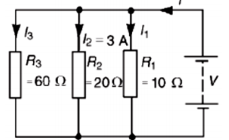

## Q10..Find the equivalent inductance of the circuit given below./7marks

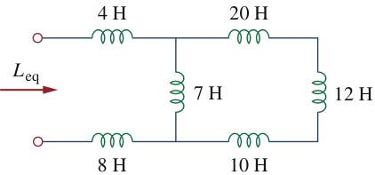

**II .SECTION B CHOOSE 3 QUESTION**

Q11.a.Calculate the equivalent inductance for the inductive ladder network given

in the circuit below/10marks

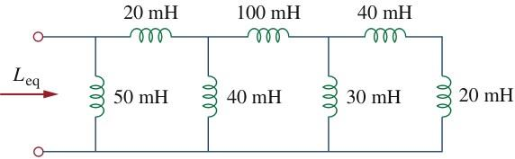

Q12.Find the equivalent capacitance seen between terminals a and b of the

circuit in the figure below/10 marks

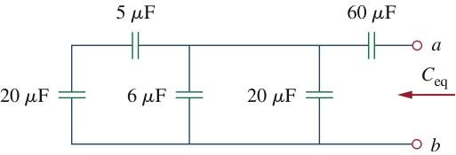

Q13.For the capacitors circuit below, determine the equivalent capacitance /10marks

**a**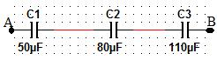

b.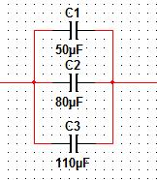

Q14.For the circuit shown in figure , determine (a) the battery voltage V (b) the total resistance of the circuit and (c) the values of resistors R1,R2 and R3, given that the p.d’s across R1, R2 and R3 are

5V, 2V and 6V respectively/10marks

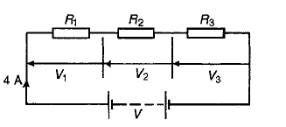

Q15.For the series-parallel arrangement shown in fig, find/10marks

(a) the supply current,

(b) the current flowing through each resistor

(c) the p.d. across each resior

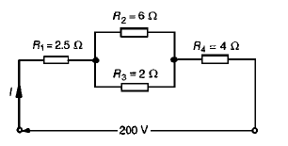

**III. SECTION C CHOOSE 1 QUESTION**

17. For the circuit shown in the figure, calculate (a) the value of resistor Rx such that the total power dissipated in the circuit is 2.5kW, (b) the current following in of four resistors/15marks

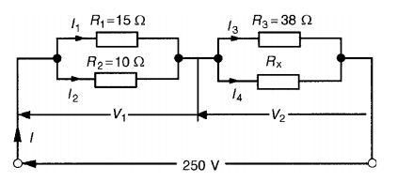

18. for given voltage in terms of v(t) =220 sin 300t .find /15marks

1. frequency in hz
2. Periode in time
3. Maximum voltage

d . Amplitude